WiFi Training Program
Module 4 – Assignment Questions
- What is the significance of MAC layer and in which position it is placed in the OSI model
The MAC (Medium Access Control) layer is a sublayer of the Data Link layer (Layer 2) in the OSI model. It plays a crucial role in controlling how devices access the wireless medium and transmit data without collisions. It ensures reliable communication through addressing, frame formatting, error control, and coordination between devices. In Wi-Fi, the MAC layer manages channel access, retransmissions, and coordination mechanisms, making it essential for efficient network performance.
- Describe the frame format of the 802.11 MAC header and explain the purpose of each fields
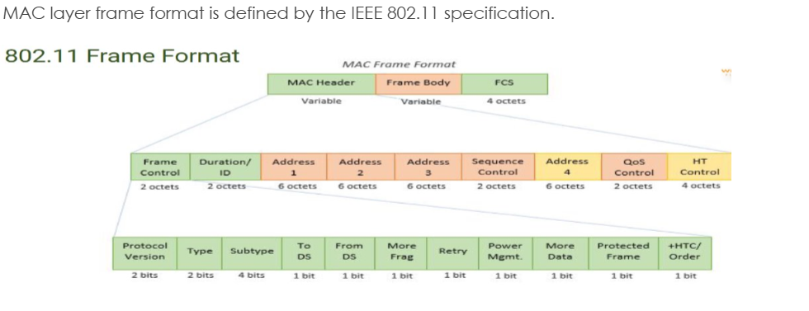
Main Fields:
- Frame Control → type (data/control/management)
- Duration → channel reservation time
- Address 1 → receiver
- Address 2 → transmitter
- Address 3 → BSSID/source/destination
- Sequence Control → ordering of frames
- Address 4 (optional) → used in special cases
- QoS Control → priority handling

- Please list all the MAC layer functionalities in all Management, Control and Data plane
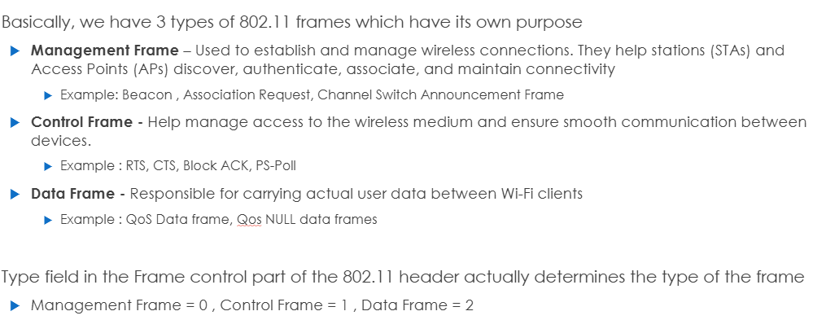
- Explain the scanning process and its types in detail
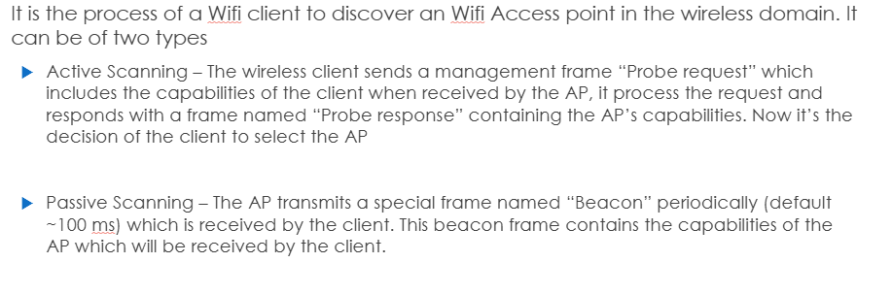
- Brief about the client association process
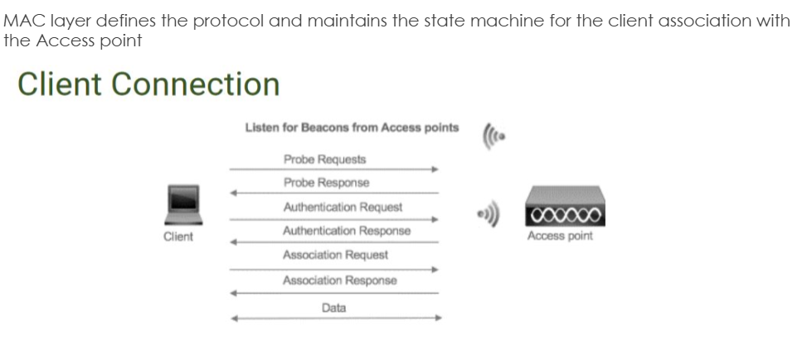
- Explain each steps involved in EAPOL 4-way handshake and the purpose of each keys derived from the process.
The EAPOL 4-way handshake is used in WPA/WPA2 security to establish encryption keys between the client and access point. In step 1, the AP sends a nonce (ANonce) to the client. In step 2, the client generates a nonce (SNonce) and derives a Pairwise Transient Key (PTK), sending the SNonce to the AP. In step 3, the AP installs the PTK and sends the Group Temporal Key (GTK). In step 4, the client acknowledges and installs the keys. This ensures secure communication and prevents replay attacks.
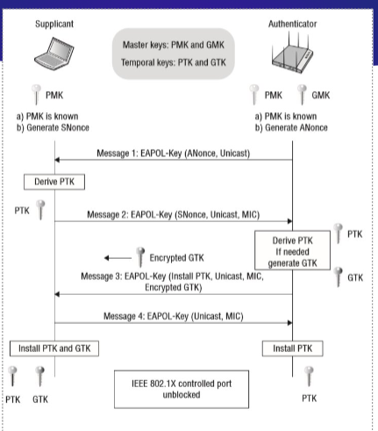
- Describe the power saving scheme in MAC layer and explore on the types of Power saving mechanisms
The MAC layer supports power-saving mechanisms to extend battery life in wireless devices. Devices can enter sleep mode when inactive and wake up periodically to check for buffered data at the access point. Mechanisms include Legacy Power Save Mode (PSM), Unscheduled Automatic Power Save Delivery (U-APSD), and Target Wake Time (TWT). These techniques reduce power consumption while maintaining connectivity.

- Describe the Medium Access Control methodologies
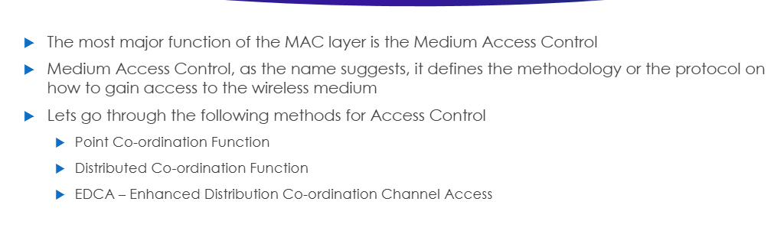
- Brief about the Block ACK mechanism and its advantages
Block Acknowledgment (Block ACK) allows multiple frames to be acknowledged together instead of individually. This reduces overhead, improves efficiency, and increases throughput. It is especially useful in high-speed networks like 802.11n/ac/ax where large amounts of data are transmitted.
- Explain about A-MSDU, A-MPDU and A-MSDU in A-MPDU
A-MSDU (Aggregated MAC Service Data Unit) combines multiple MSDUs into a single frame to reduce overhead. A-MPDU (Aggregated MAC Protocol Data Unit) aggregates multiple MPDUs, each with its own header and error checking. A-MSDU in A-MPDU is a hybrid approach where multiple MSDUs are first aggregated and then included inside an A-MPDU. These aggregation techniques significantly improve throughput and efficiency in modern Wi-Fi networks.
